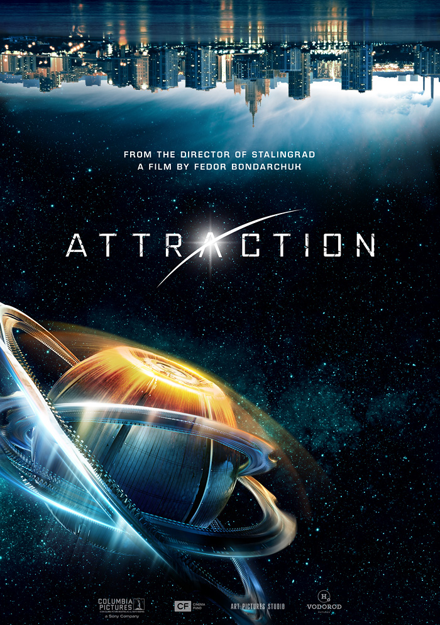

**CREW AND CAST**

**Director:** Fedor Bondarchuk

**Screenplay:** Oleg Malovichko, Andrey Zolotarev

**Camera:** Mikhail Khasaya

**Producers:** Fedor Bondarchuk, Dmitry Rudovskiy, Mikhail Vrubel, Alexander Andryuschenko, Anton Zlatopolsky

**Music by:** Ivan Burlyaev

**Visual effects:** Main Road Post

**Art director:** Zhanna Pakhomova

**Costume designer:** Tatiana Mamedova

**Sound supervisors:** Sergey Bolshakov, Andrey Belchikov

**Production:** Art Pictures Studio, Vodorod

**Release date in Russia:** Jan. 26, 2017

**Distributor in Russia:** WDSSPR

**Starring:** Irina Starshenbaum, Aleksander Petrov, Rinal Mukhametov, Oleg Menshikov, Sergey Garmash, Ludmila Maksakova

**WHAT IS THE ATTRACTION?**

*Attraction* is a new work by Fedor Bondarchuk, the director of Russia’s box-office champion Stalingrad. It’s a bold and offbeat project – the first Russian movie about an extraterrestrial invasion. It’s an epic sci-fi story of how the life of mankind changes after a mysterious flying object crash-lands in Moscow… It is a delicately told heart-piercing story of people trying to get used to the new life, understand each other and embrace an unknown future through the tough times. *Attraction* is a spectacular action movie packed with stunningly convincing CGI.

**Fedor Bondarchuk, Director and Producer, Art Pictures Studio**: *“When guys from “Vodorod” team approached us with the idea of Attraction, at first it caught my interest as a producer: it’s sci-fi, with cool special effects and action scenes, the plot has some twists in it. But as we were working on the script, the future film started growing on me as a director, with its depth, the ideas behind it, it made me really excited! Without no moral preaching and no big words it addressed the topics of forgiveness and accepting the things from beyond our normal routine, the topic of aggressive environment, which we are all part of, regardless of our nationality or religious beliefs. It’s a world where people can no longer hear each other. In our film aliens are a means, a tool to show how far mistaken we can all be. The film locations are Moscow’s outskirt residential districts with their typical apartment blocks, streets, parks, playgrounds, clubs and parking houses.*

**ON THE SPECIAL EFFECTS IN THE FILM**

High profile domestic and international filmmaking experts were engaged in the production of this complex and high tech project, including top Russian visual effects studio MainRoad Post led by Arman Yakhin, whose portfolio includes computer graphics production for *Wanted*, *August. Eighth*, *Metro*, *Stalingrad*, and others; and the sound design was created by Dave Whitehead (New Zealand), who is famous for his work in *King Kong*, *District 9*, *Elysium*, Arrival and *The Hobbit* trilogy.

**Arman Yakhin, CEO Main Road Post**: *Attraction is my third movie with Fedor Bondarchuk. The previous project I did with him was Stalingrad. Attraction is unique. It took us more than a year, we had more than 1100 computer generated shots, some of which were more challenging than what we had ever dealt with before. We had a lot of different ideas, but Fedor would always know exactly what he wanted. He even knew what the spaceship should look like. He told us it had to have a round shape, like an electron, and so we made it. The episode where the sphere barges into the ground was the most difficult. There were helicopters, buildings collapsing. More than 100 people worked on this one.*

The scenes with aliens were shot using stunts wearing MotionCapture sensors. However, some stunts were performed by the actors themselves. Some features of the aliens will come as a surprise to viewers.

**Sound designer Dave Whitehead** and Fedor Bondarchuk invented a whole new audio world for the aliens, including an original tongue and sounds: *Fedor came up with a great idea, so that the aliens’ nature and technologies were based on water state. I would drop a giant tube which had a mic at the end into the ocean water and this way I could record all sounds and plumps.*

**Fedor Bondarchuk, Director and Producer**: *Chertanovo district for the movie was designed and created by the Main Road Post team. This whole place is CGI, it’s inhabited by digital people, digital cars on the streets, traffic lights, kids on playgrounds, electronic shop signs, this is all a digital world, which was first taken down to pieces with computer graphics and then reconstructed again. Basically, some 50% of the film is CGI. It’s a real CGI feast. Also, we had an agreement with IMAX that we would continue our successful cooperation after Stalingrad. We showed them a presentation of scenery designs and the world that we created for Attraction, and also some CGI-enhanced real city images.*

*Attraction* is the fourth Russian movie released in IMAX®.

**John Schreiner, Senior VP for Business Development IMAX in Russia and CIS**: *“We can’t wait for the new film by Fedor Bondarchuk – Attraction. It’s a huge film with state-of-the-art visual effects and an exciting plot which is obviously made for IMAX 3D.”*

**DID YOU KNOW?**

* Attraction is the first Russian film about an extraterrestrial invasion.
* The film shoot began in October 2015 and lasted more than 3 months (85 shifts).
* The producers from Vodorod Company Mikhail Vrubel and Alexander Andryuschenko shared the idea of *Attraction* with Fedor Bondarchuk while filming the comedy *Ghost*, where Bondarchuk played the leading role – pilot Yury Gordeev.
* The screenplay for *Attraction* was written by Oleg Malovichko and Andrey Zolotarev, authors of *Ghost* and several other box office hits.
* Fedor Bondarchuk initially planned to only produce *Attraction*, but after he read the draft of the screenplay he just couldn’t stop thinking about it.
* A confidentiality agreement was signed with every single member of the film crew before the shooting began. For the first time in Russian filmmaking history, mobile phones were not allowed on the set, and their cameras were sealed with special non-transparent stickers.
* The larger part of the film shoot took place in North Chertanovo, around the female lead’s “home” and “school”, and some local streets were filmed too.
* The graffiti in *Attraction* were created by Oleg Basket and Misha Most. Basket is one of the first graffiti artists and the pioneer of the hip hop movement in Russia. His most famous works can be found in Moscow’s most emblematic neighborhoods, such as Khokhkovka, and since recently they can also be spotted in North Chertanovo. Most is an artist and graffiti writer, member of ZACHEM crew, and project manager for several street art initiatives.
* A set of three floors of a typical apartment block in Chertanovo was built in a pavilion, to be then destroyed by the crash-landed UFO. This is where Julia and Artyom (Starshenbaum and Petrov’s characters) were at the moment of the crash.
* The casting for *Attraction* lasted for almost a year, hundreds of young Russian actors auditioned to take part in the film.
* Lead actress Irina Starshenbaum had to film for *Attraction* in daytime after shooting another motion picture at night, so she could only have a nap on the ride. On the set she had a doctor keeping an eye on her state of health.
* During one of the shots Alexander Petrov broke through a glass door with his leg and suffered a serious ligament rupture. He had to use a pair of crutches for a few months, but it almost didn’t affect the filming schedule, Petrov was willing to do all his scenes himself (sometimes, standing on one foot), without a stunt man.
* When Oleg Menshikov agreed to take part in Attraction, Fedor Bondarchuk at first couldn’t believe his luck. Menshikov is famously picky about his roles, and for Bondarchuk it was a long-time dream to work with him as a director.
* Fedor Bondarchuk couldn’t imagine the film without Sergey Garmash, who has been his actor talisman for many years. Garmash didn’t think twice and agreed to take the part straight away.
* Impeccably knotted ties on deputy prime minister – Sergey Garmash’s character – was the work of Fedor Bondarchuk himself, famous for his exceptional sense of style.
* Visual effects for *Attraction* were created by MainRoadPost Studio (*Stalingrad*): it took a team of 250 specialists more than 7,000 hours to create CGI for the film.
* Dave Whitehead from New Zealand designed the sound in *Attraction*. His previous works include *King Kong*, *The Hobbit*, *District 9*, and most recently – *Arrival*.
* The film features some Russian-made military equipment: armored vehicles, helicopters, robots, pilotless aircrafts, and even heavy aircraft carrying cruiser “Admiral Kuznetsov”.
* Oleg Menshikov’s character uses the Russian multi-purpose SUV “Tiger” (based on GAZ), and URAL-based “Taifuns” take the kids to school to ensure their safety without changing their normal life routine.
* For the first time filmmakers were allowed onto “Admiral Kuznetsov” aircraft carrier to film fighters flying scene from the beginning of the movie. Hero of the Russian Federation test pilot Oleg Mutovin, who has landed a fighter plane onto the ship numerous times throughout his carrier, took part in the film.
* Consultants featured on the preparation stage included active military servants from the navy, aerospace forces, ground forces, EMERCOM of Russia and Ministry of Internal Affairs.
* To date, *Attraction* has been sold to more than 74 countries of the world.

**MUSIC AND SOUNDTRACK**

Music for the film was composed by Ivan Burlyaev, famous for his work in *Ghost* and *We Are from the Future*. Burlyaev also wrote an original song called “Closer” performed by Paulina Andreeva. This track was featured on the first trailer for the film. It was also included into the special sound track along with works by several popular rap and hip hop artists, such as Basta, L’One, Max Korzh, Griby, Scriptonit and many others.

**CREW**

**Fedor Bondarchuk, Director and Producer, Art Pictures Studio:** *To me the title of our movie is self-explanatory: everything was new for me, even the crew who we made the film with, new and young people. Our cooperation was an exciting exchange and attraction of energies.*

**Dmitry Rudovsky, Producer of Art Pictures Studio**: *As a producer, I was compelled by the idea of Attraction because the story takes place in our city, in the setting we are all so familiar with, it’s where we live. There are films about aliens destroying New York, Los Angeles, London, but not Chertanovo or Mitino. And we use a sci-fi plot to tell the story of human feelings and emotions, and how they are tested in an extreme situation. Attraction is a film about all of us, it’s a film about love.*

**Mikhail Vrubel, Producer of Vodorod company, Author of the idea**: *We are convinced that we were able to blend a big sci-fi blockbuster with nuanced and meaningful social notions. When we first pitched the idea our colleagues from Art Pictures Studio supported it, and after Fedor agreed to direct the film the project reached its final shape. Cooperation with IMAX Corporation made all the sense for Attraction, and we are proud to deliver the fourth Russian film released in this format. Actually, you can’t imagine such an epic sci-fi project without IMAX, it is the only way you can experience a complete range of emotions from the film. Attraction is distributed by Walt Disney Studios Sony Pictures Releasing, leader of the Russian market. The best Russian and international filmmaking industry professionals collaborated for this film, and we are convinced that the result of their work will meet the highest standards.*

**Alexander Andryuschenko, Producer of Vodorod company, Author of the idea**: *Attraction is a film, which pushes the boundaries of a traditional blockbuster: disguised as a global sci-fi disaster, it addresses today’s issues, modern human drama. Set in our contemporary world, the story required a brand new approach to details, fresh and bold solutions. So the nature of the project itself dictated the need for a young and audacious crew. Guided by a mature and skillful director it has brought an incredible result. Fedor Bondarchuk had already discovered new acting talents before, but on Attraction he was able to achieve even more than that – he introduced viewers to a brand new generation of filmmakers with their fresh and innovative take on cinema.*

**Anton Zlatopolsky, Producer, first deputy general director of the All-Russian State Television and Radio Broadcasting Company, general director of Rossiya 1 TV channel**: *We have always taken some part in all major national projects: Legend №17, The Crew, Stalingrad. I think that Attraction stands in the same line. We have absolute trust in the story, in the director, in the whole filmmaking process.*

**Mikhail Khasaya, Operator**: *I was very happy that Fedor watched my first movie Cold Front, which led him to invite me to work on Attraction. Interestingly, before this project he had never shot a film in Moscow, and finding the right locations for a sci-fi action film was a challenge, but when your director knows exactly what he wants, it makes life easier for everyone on the crew. On set we all worked like a single entity, as if we were in cahoots. For instance, it turned out that Alexander Petrov loves to work with a hand-held camera, to have a direct contact with it, and I loved it too. Also we were lucky with our female lead, Irina Starshenbaum is a very organic actor. As for Rinal Mukhametov, he is an old friend of mine, so bottomline is that working on Attraction was an absolute blast.*

**Oleg Malovichko, screen writer**: *Aliens is a metaphor. Actually, this is a film about people capable to understand and accept someone different from them, and about the girl’s difficult path to love. I find it great that Fedor Bondarchuk is one of those directors who can make a film, which has both – a human story and compelling special effects, which tickle your imagination.*

**Andrey Zolotarev, screen writer**: *Attraction is the best way to tell a story about us, people, through aliens, but it’s challenging, because how do we know what they are really like, and I mean not only what they look like, but what are their motives? Are they intelligent, do they seek contact with us? It wasn’t easy to find answers to these questions, we spent a lot of time arguing about their motives.*

**ACTORS**

Casting calls lasted a long time – a few months, but it was worth it: the final cast was an ideal bunch of young actors supported by some of Russia’s beloved film and theater artists. The lead roles went to Irina Starshenbaum, Alexander Petrov, Rinal Mukhametov and Oleg Menshikov. Supporting acts also include some acclaimed personalities, such as Sergey Garmash, Ludmila Maksakova, Nikita Kukushkin, Evgeny Sangadjiev, Alexey Maslodudov, and many others.

**Fedor Bondarchuk, Director and Producer Art Pictures Studio**: *Many people think that Russia does not have a new generation of talented filmmakers. That is rubbish! We have some incredible young actors, and they are completely different from us! The work on this project was an exciting energy exchange. I got to see so many young talents, and I believe I was able to pick the best of the best.*

Irina Starshenbaum is a new face on the big screen, but young viewers know her from popular TV series *Rooftop of the World* (CTC), *Jackal* (Channel One) and *Olga* (TNT). *Attraction* is the first big film in the talented actress’ portfolio.

**Irina Starshenbaum, leading actress**: *For me Attraction is first and foremost a story about moving into adulthood. Julia (Starshenbaum’s character) same as many other teenagers just goes with the flow and doesn’t look far ahead into the future. But deep inside, she wants something different. Her dream is that someone rocks her familiar world and takes her up to a different level. And her dream comes true…in a very unexpected manner. The spaceship crash completely changes her life. When Julia finds herself in the eye of the storm, there is not a trace of that light-hearted and selfish teenager she used to be. She becomes a real hero, capable to take actions and chances, make sacrifices, and love.*

**Alexander Petrov** is an up-and-coming young actor, who has come to prominence with his roles in TV series *Policeman from Rublevka*, *Fartsa* and *Method,* and also in *Yolki 3* and *The Elusive*. He plays Hamlet in the eponymous play by Shakespeare and Lopakhin from Tchekov’s *The Cherry Orchard* in Moscow’s leading theatre companies.

**Alexander Petrov, actor**: *Artyom (Petrov’s character) is your typical down to earth guy who has never been fortune’s favorite. From early age he had to learn to survive, and he grew up to be a fighter, with clear-cut and simple beliefs. He loves his neighborhood, his friends, and his girl-friend. And when their well-being is compromised, he stands up to defend what he loves and doesn’t think twice, even if the source of the threat is an alien invasion. We all know a guy like Artyom. It is as if he came into our film right from the city streets. I had to be very natural in this role, it was very challenging emotionally. For me as an actor, Attraction is a giant leap forward. In my opinion, this is an unprecedented project for our filmmaking industry.*

**Rinal Mukhametov** is an apprentice of Kirill Serebrennikov, well-known among the theatre-going public for his striking performance in numerous plays from the much-talked-off Gogol-Center in Moscow. He has already had a big break with several leading roles in television and film projects, but *Attraction* is his first blockbuster.

**Rinal Mukhametov, actor**: *Attraction is a film about mutual understanding, something we don’t see these days. It’s a global topic, and a very relevant one for our times. The idea of Attraction is that you should stop for an instant and think, maybe I should open my eyes and listen to those who don’t look like me? Maybe it’s an opportunity to discover something new about us? Attraction tells us how we can change. It is gratifying to see how Fedor Bondarchuk really cares about what the younger generations are up to. He really wants to understand their way of thinking. I’m grateful for this opportunity to speak out.*

**Oleg Menshikov** is a renowned Russian actor, winner of Russia’s State Prize and other awards. His track record includes more than 30 film roles and collaboration with Russia’s top directors. He is the only Russian actor to win the high-profile Lawrence Olivier Award for his portrayal of Esenin in London’s Globe theatre. Menshikov is artistic director of M.N.Ermolova Theatre, and founder of Theatrical Partnership 814. He was one the leads in such legendary Russian films as *The Pokrovsky Gate*, *Burnt by the Sun* (Academy Award (Oscar) for Best Foreign Language Film and the Grand Prize of the Jury at the 47th Cannes Film Festival), *Barber of Siberia*, *The State Counsellor*, *Doctor Zhivago*, *Legend* *№17* and etc.

**Oleg Menshikov, actor**: *I agreed to take part in Attraction because I always go with my intuition. And in this case the puzzle just came together: firstly, I’ve always had interest in Fedor’s works. And I was curious to understand who Bondarchuk is as a director. Secondly, the plot – this is something new for our cinema, and besides, it is well thought-out and written. The screenplay had many signs that the film would work: on the social, genre and acting levels. And certainly one of the most important factors for me was the number of young artists engaged in the project. I have to say that Fedor kept surprising me throughout the filming – first as a professional, and then as a human being, I discovered a Bondarchuk I didn’t know before. I am convinced that Attraction will plant its ideas in everyone, there are enough layers to this film, that make you think in very different directions. I think that this film can cut to the heart.*

**Sergey Garmash** is one of the most famous theatre and film actors in Russia, People’s Artist of the Russian Federation, who has played more than 95 film roles and about 30 roles on the TV. His works include *12* by Nikita Mikhalkov, *Stilyagi* and *The Lover* by Valery Todorovsky, *Kray* by Alexey Uchitel, *72 meters* by Vladimir Khotinenko, *Home* by Oleg Pogodin and many others. In 1984, Sergey Garmash graduated from Moscow Art Theatre School and joined Moscow Sovremennik theatre. Over the years Garmash has become one of the leading actors of the theatre with an interesting and wide list of productions. In 2009, Sergey Garmash debuted as theatre director, when he brought his version of *Murlin Murlo* play back onto Sovremennik’s stage.

**Sergey Garmash, actor**: *The most valuable thing about Attraction is this message it sends the younger generations, it is a very important and a very timely message.*